**Concepts of Operating System**

**Assignment 2**

**Part A**

What will the following commands do?

1)• **echo "Hello, World!"**  
Prints Hello, World! to the terminal.

2)• **name="Productive"**  
Sets a variable named name with the value "Productive". This variable is stored in the current shell session.

3)• **touch file.txt**  
 Creates a new empty file named file.txt if it does not already exist. If the file already exists, it updates the file's timestamp to the current time.

4)• **ls -a**  
 Lists all files and directories in the current directory, including hidden files (those starting with a .).

5)• **rm file.txt**  
 Remove the file named file.txt.

6)• **cp file1.txt file2.txt**  
Copies the contents of file1.txt to a new file named file2.txt. If file2.txt already exists, its contents are overwritten.

7)• **mv file.txt /path/to/directory/**  
Moves file.txt to the specified directory /path/to/directory/.

8)• **chmod 755 script.sh**  
Changes the permissions of the file script.sh to 755, which means the owner can read, write, and execute the file, while others can only read and execute it.

9)• **grep "pattern" file.txt**  
Searches for the string "pattern" in the file file.txt and prints each line that contains the pattern.

10)• **kill PID**  
Sends a termination signal to the process with the specified PID (Process ID), effectively stopping it. You would replace PID with the actual number of the process.

11)• **mkdir mydir && cd mydir && touch file.txt && echo "Hello, World!" > file.txt && cat file.txt**  
 Creates a new directory named mydir, navigates into it, creates an empty file named file.txt, writes Hello, World! into file.txt, and then displays the contents of file.txt.

12)• **ls -l | grep ".txt"**  
Lists all files in the current directory in long format (showing detailed information) and filters the results to show only those containing .txt in their names.

13)• **cat file1.txt file2.txt | sort | uniq**  
Concatenates the contents of file1.txt and file2.txt, sorts the combined output, and filters out any duplicate lines, displaying only unique lines.

14)• **ls -l | grep "^d"**  
Lists all files and directories in the current directory in long format, then filters the results to show only directories. The ^d regex matches lines that begin with a d (indicating a directory in the ls -l output).

15)• **grep -r "pattern" /path/to/directory/**  
 Recursively searches for the string "pattern" in all files within the directory /path/to/directory/ and its subdirectories.

16)• **cat file1.txt file2.txt | sort | uniq -d**  
Concatenates the contents of file1.txt and file2.txt, sorts the combined output, and then displays only duplicate lines (those that occur more than once).

17)• **chmod 644 file.txt**  
Changes the permissions of file.txt to 644, which means the owner can read and write, while others can only read.

18)• **cp -r source_directory destination_directory**  
 Recursively copies the contents of source_directory to destination_directory. If destination_directory does not exist, it is created.

19)• **find /path/to/search -name "*.txt"**  
Searches for files ending with .txt within the directory /path/to/search and all its subdirectories.

20)• **chmod u+x file.txt**  
Adds execute permission for the user (owner) of file.txt.

21)• **echo $PATH**  
Displays the value of the PATH environment variable, which lists the directories the shell searches for executable files.

**Part B**

Identify True or False:

1. ls is used to list files and directories in a directory.

Ans: True

2. mv is used to move files and directories.

Ans: True

3. cd is used to copy files and directories.

Ans: False

4. pwd stands for "print working directory" and displays the current directory.

Ans: True

5. grep is used to search for patterns in files.

Ans: True

6. chmod 755 file.txt gives read, write, and execute permissions to the owner, and read and execute permissions to group and others.

Ans: True

7. mkdir -p directory1/directory2 creates nested directories, creating directory2 inside directory1 if directory1 does not exist.

Ans: True

8. rm -rf file.txt deletes a file forcefully without confirmation.

Ans: True

Identify the Incorrect Commands:

1. chmodx is used to change file permissions.

Ans: Incorrect because correct command is chmod.

1. cpy is used to copy files and directories.

Ans: Incorrect because correct command is cp.

1. mkfile is used to create a new file.

Ans: Incorrect because correct command is touch filename.

1. catx is used to concatenate files.

Ans: Incorrect because correct command is cat

1. rn is used to rename files.

Ans: Incorrect because correct command is mv.

Part C

Question 1: Write a shell script that prints "Hello, World!" to the terminal.

Ans: 1) Create shell file by using command: vi filename.sh.

2)Add content to be print .

3)For saving the file press Shift+: wq.

4) give last command for print output: bash filename.sh.

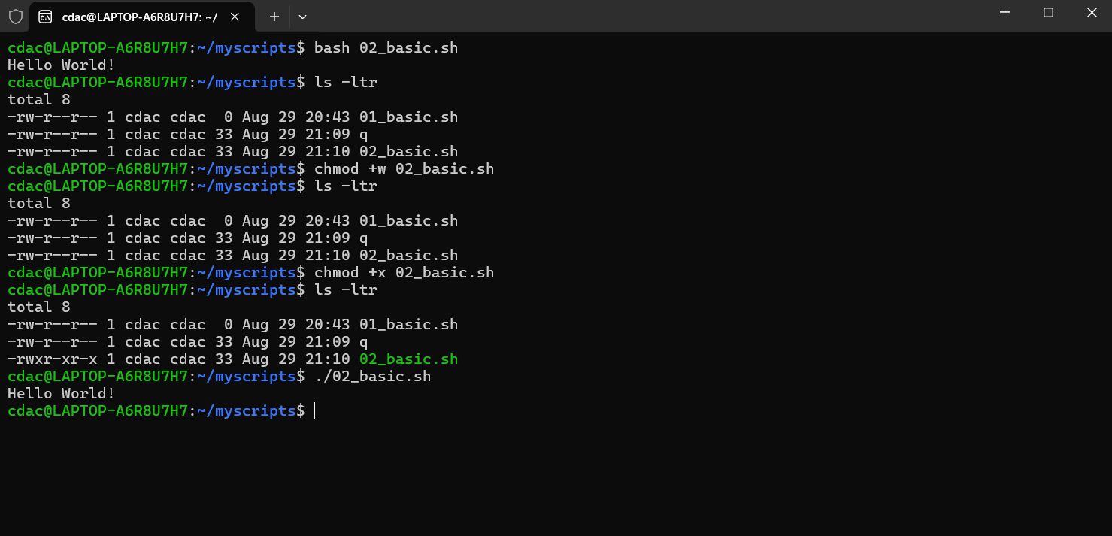

Question 2: Declare a variable named "name" and assign the value "CDAC Mumbai" to it. Print the value of the variable.

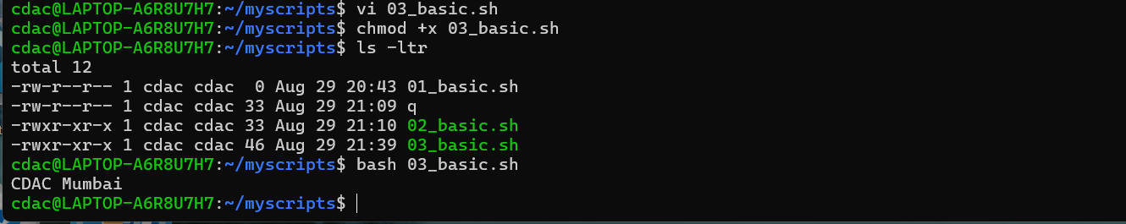

Question 3: Write a shell script that takes a number as input from the user and prints it.

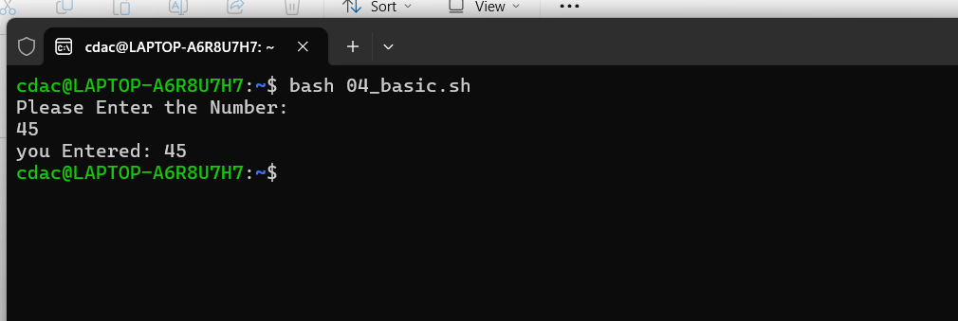

Question 4: Write a shell script that performs addition of two numbers (e.g., 5 and 3) and prints the result.

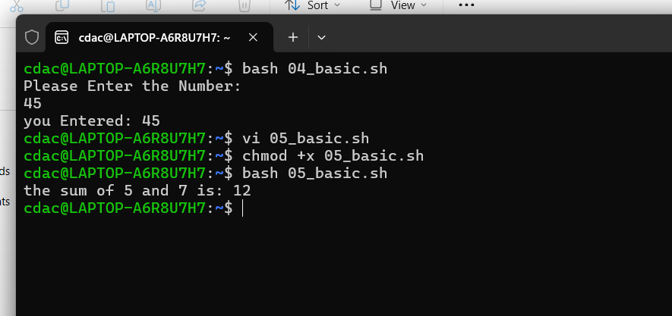

Question 5: Write a shell script that takes a number as input and prints "Even" if it is even, otherwise prints "Odd".

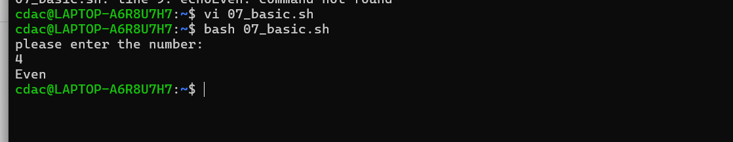

Question 6: Write a shell script that uses a for loop to print numbers from 1 to 5.

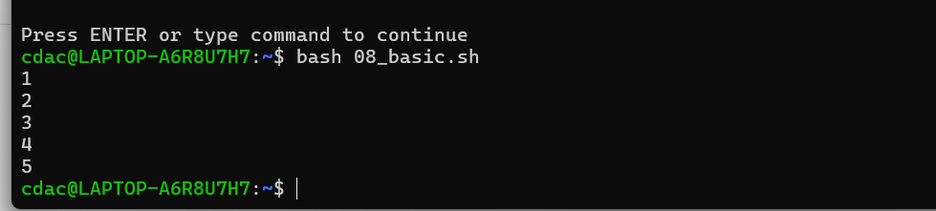

Question 7: Write a shell script that uses a while loop to print numbers from 1 to 5.

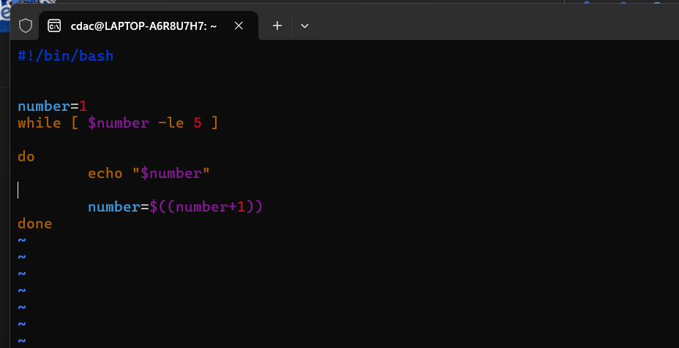

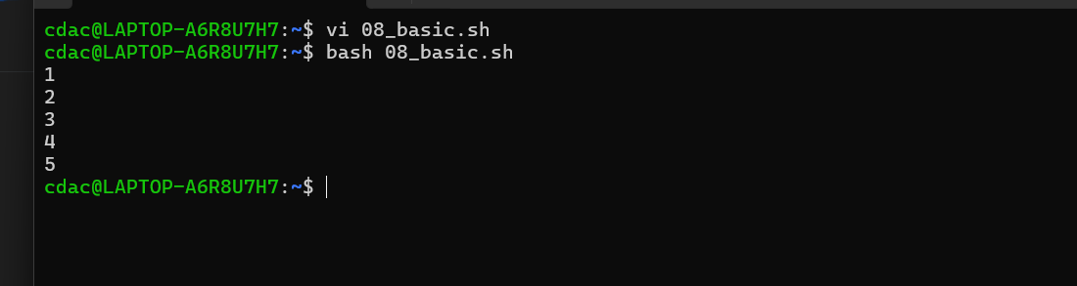

Question 8: Write a shell script that checks if a file named "file.txt" exists in the current directory. If it does, print "File exists", otherwise, print "File does not exist".

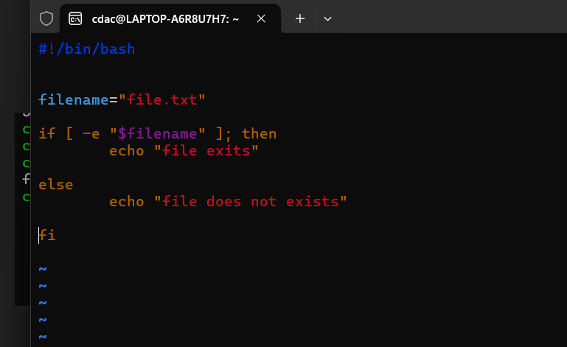

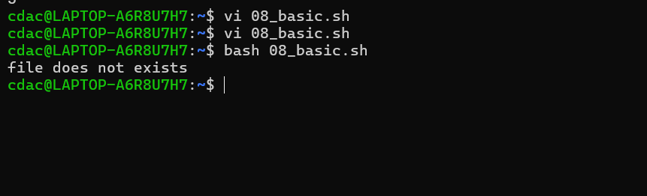

Question 9: Write a shell script that uses the if statement to check if a number is greater than 10 and prints a message accordingly.

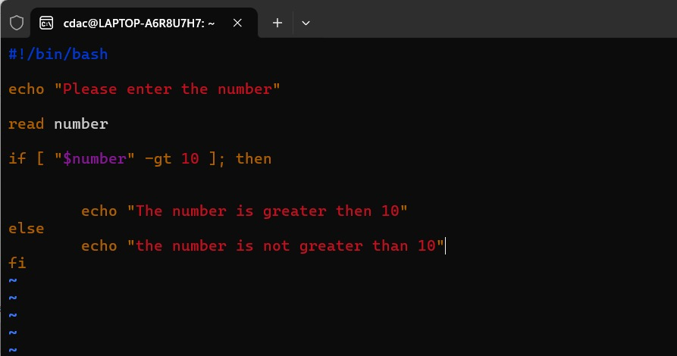

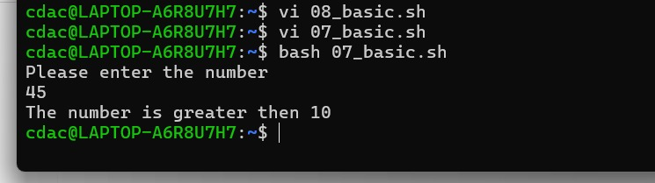

Question 10: Write a shell script that uses nested for loops to print a multiplication table for numbers from 1 to 5. The output should be formatted nicely, with each row representing a number and each column representing the multiplication result for that number.

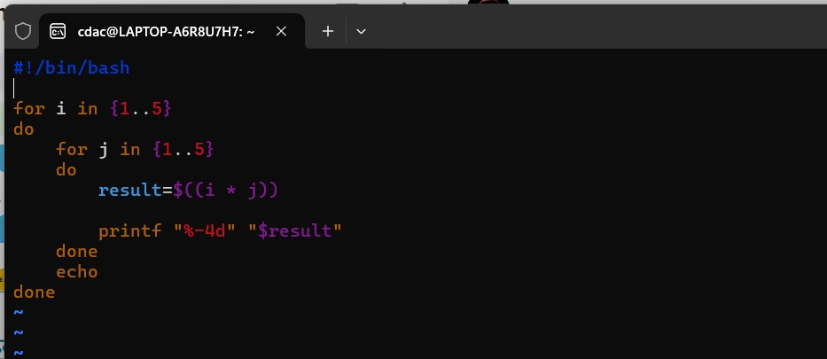

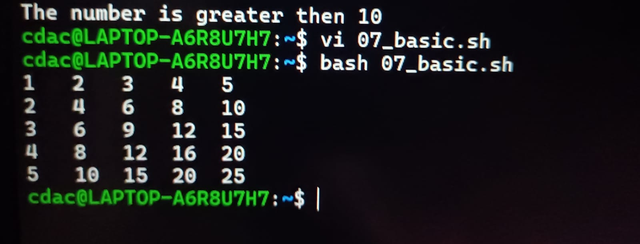

Question 11: Write a shell script that uses a while loop to read numbers from the user until the user enters a negative number. For each positive number entered, print its square. Use the break statement to exit the loop when a negative number is entered.

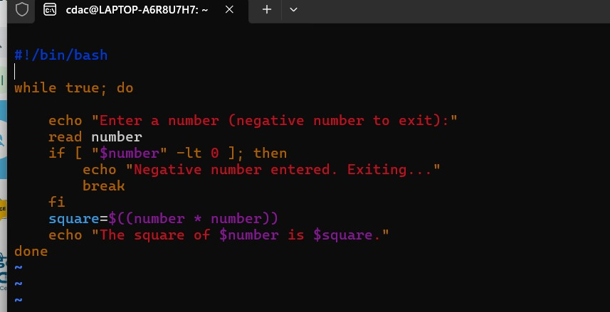

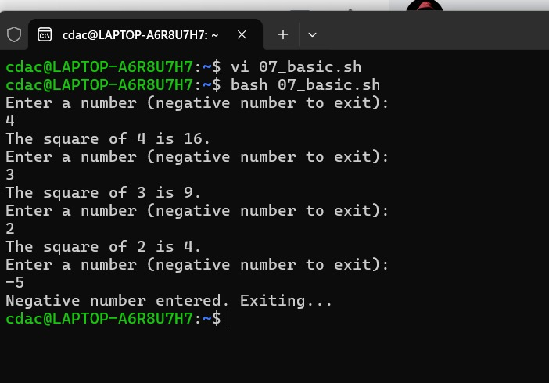

**Part E**

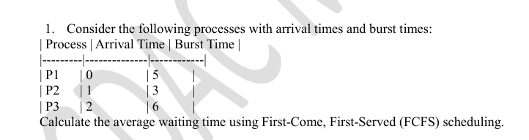

**Average waiting time = 3.33.**

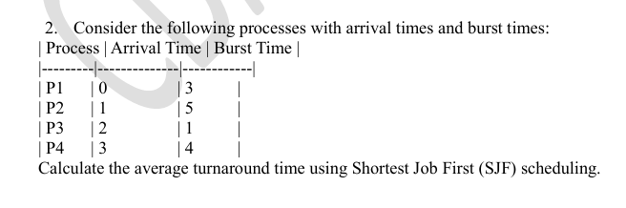

**Average Turn around time = 5.5**

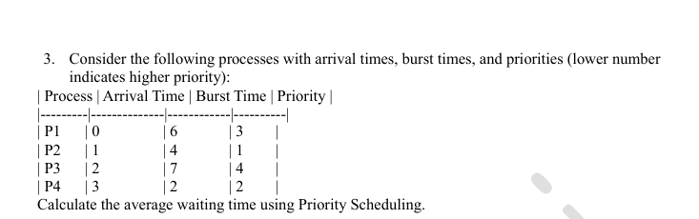

**Average Waiting Time = 5.**

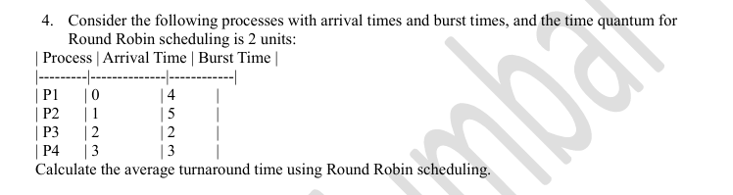

**Average Turn around Time = 9.25.**

**5. Consider a program that uses the fork() system call to create a child process. Initially, the parent process has a variable x with a value of 5. After forking, both the parent and child processes increment the value of x by 1. What will be the final values of x in the parent and child processes after the fork() call?**

**Ans :**

**Before fork() Call:**

* + **Parent's x = 5**

**After fork() Call:**

* + **Parent Process: Increments x by 1.**
    - **Parent's x becomes 5 + 1 = 6.**
  + **Child Process: Increments its own copy of x by 1.**
    - **Child's x also becomes 5 + 1 = 6.**

**In the Parent Process: x = 6**

**In the Child Process: x = 6 .**